 PRIVATE room lunch menu

From the kitchen of Chef Barak Aharoni

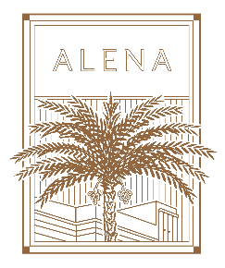

**appetizers**

A selection of Chef Barak Aharoni’s seasonal appetizers

Fresh Rye bread baskets served with olive oil

**main dishes** (Individual Selection)

Beef fillet with grilled onion & aromatic peppery jus

Catch of the day, served with cherry tomatoes, Kalamata olives & oregano

Grilled chicken with preserved lemon, rosemary, Kalamata olives & kale

Seasonal risotto & Parmesan

**side dishes**

Green salad

Pomme purée

French fries

**DESSERTS**

(Please choose two of them)

Chocolate nemesis

Lemon pie

Barak`s bread pudding

Panna cotta

**BEVERAGES**

Acqua Panna & San Pellegrino

Pots of filter coffee & tea selection

price: 250 nis + vat per person (boardroom&PDR)

price: 350 nis + vat per person (conservatory&tower garden)

** Sunday-thursday